Mr Llewellyn C Russell AM
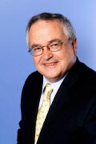

He has a Bachelor of Economics degree from Queensland University in and a Master of Business Administration Degree from the Heriot –Watt University in Edinburgh. Appointed to the Commonwealth Public Service in 1969 and spent most of his time there in the Transport Department. He joined the secretariat for the Australia to Europe Shipping Conference in 1981. He became the Executive Director of various organisations involved with promoting the interests of shipping Line members before being appointed the inaugural CEO of Shipping Australia Ltd in 2001, retiring in 2013. He was President of the State Chamber of Commerce in NSW from 1998 to 2001 and a Director of the Australian Chamber of Commerce and Industry over the same period. He is a graduate of the Australian Institute of Company Directors and a Fellow of the Chartered Institute of Logistics and Transport. He received the award of a Member of the Order of Australia in 2009 for services to shipping, trade and business associations.
He was a Councillor of the Australian Mariners' Welfare Society for sixteen years , resigning in November, 2024. He was appointed a Trustee of the Sydney Bethel Union in July 2014, Deputy Chairman in December 2021 and Chairman in August 2023.
David Parmeter

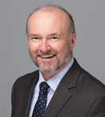
David holds a Bachelor of Commerce (Industrial Relations) from University of New South Wales, Diploma of Commercial Shipping Practice, a Bachelor of Laws and Diploma of Legal Practice from University of Technology Sydney, and has been admitted as a Solicitor of the Supreme Court of NSW.
After graduation from UNSW, David commenced employment as an Industrial Relations Officer with BHP at the Port Kembla steelworks. Subsequently he joined ANL and started a long association with the shipping and maritime industries.
From 1987 to 2001 David held a variety of different roles with what was then called the Australian Shipowners Association. In 2002 he joined Teekay Shipping (Australia) Pty Ltd, the local subsidiary of a large multinational shipping company, as head of Human Resources. In late 2006 David was appointed Managing Director, a position he held until May 2018.

While MD of Teekay Australia, David was invited to join the Council of Australian Mariners Welfare Society, and currently is Chairman. He was appointed a Director of the Sydney Bethel Union in November 2019 and Deputy Chairman in August 2023.

Mr Derek G Lightfoot


Derek was educated at Barker College and Sydney University, graduating with a Bachelor of Economics in 1979. He qualified as a Chartered Accountant with PricewaterhouseCoopers, working in their Sydney and Hong Kong practices.

He subsequently held a senior management position with the Hong Kong Airport Authority, before moving back to Sydney in 1997 to join StarTrack, a major Australian transport company. He was appointed CEO in 2003, managed the sale process on behalf of the founder and worked closely for many years with the purchasers, Qantas and Australia Post.

Derek subsequently joined GMK Logistics, a national transport and logistics business, serving as CEO for over 10 years. He is currently a business and corporate advisor to Degotardi, Smith & Partners, a leading surveying business based in Sydney. He was appointed a Director of the Sydney Bethel Union in August 2021.

Mr Shane Hobday
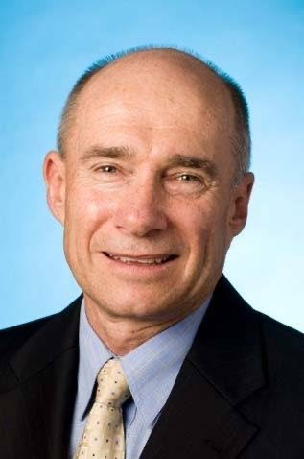
Shane has a Bachelor of Engineering (Mechanical) from Newcastle University and is a graduate of the Australian Institute of Company Directors. He has over 35 years of experience in the port industry in NSW having held senior executive operational roles in both the government and private port operator organisations from 2000 to 2016.
In addition, Shane was Chair of the Safety and Security Committee of International Association of Ports and Harbours between 2010 - 2013.

He was the Chair of the Sydney Seafarer Welfare Committee from 2017 - 2024 and until November 2021 was a Director of the Mission to Seafarers, Sydney. He was appointed a Director of the Sydney Bethel Union in December 2021 and has also been a Councillor of the Australian Mariners Welfare Society since 2024.

Mr James AM Cowper

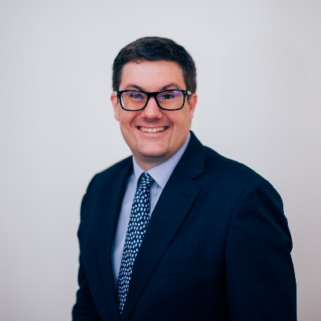
James holds a Bachelor of Arts and a Master of Commerce, majoring in Finance and Commercial Law, from the University of Sydney. He is a Chartered Financial Analyst (CFA Charterholder).

James is a Director at Principle Advisory Services, a leading Australian investment management advisory and distribution firm. James covers the Australasian institutional investor market and specialises in private markets investments - namely, private equity/venture capital, alternative credit strategies and unlisted real assets.
From 2016 to 2024, James was a Director of the CFA Society Sydney. In 2020, James was appointed Treasurer of CFA Society Sydney and joined the Investment Committee responsible for the management of the Society’s financial reserves.
He was appointed a Director of the Sydney Bethel Union in February 2022.
James was named one of Private Equity International’s (PEI) 40 under 40: Future Leaders of Private Equity in 2020.

